**Unity Catalog**

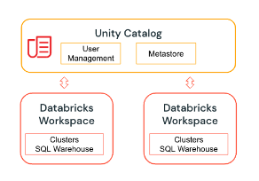

Unity Catalog is a governance solution for data and AI on the Databricks platform. It offers a central place to administer and audit data access, as well as data discovery capabilities. The Unity Catalog object model are as follows:

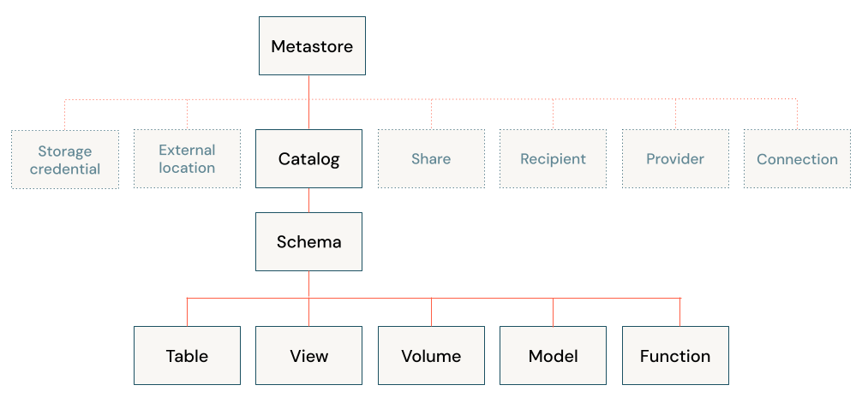

* **Metastore**: The top-level container for metadata. Each metastore exposes a three-level namespace (catalog.schema.table) that organizes your data.
* **Catalog**: The first layer of the object hierarchy, used to organize your data assets.
* **Schema**: Also known as databases, schemas are the second layer of the object hierarchy and contain tables and views.
* **Tables, views, and volumes**: At the lowest level in the data object hierarchy are tables, views, and volumes. Volumes provide governance for non-tabular data.
* **Models**: Although they are not, strictly speaking, data assets, registered models can also be managed in Unity Catalog and reside at the lowest level in the object hierarchy.